REGISTRATION IS OPEN!
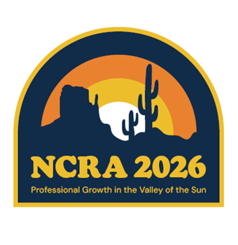
45th National Conference of Regulatory Attorneys
Phoenix - Scottsdale, Arizona
May 3 – 6, 2026
Professional Growth in the Valley of the Sun

Join us in Phoenix – Scottsdale, Arizona May 3 – 6, 2026 for the 45th Annual National Conference of Regulatory Attorneys (NCRA 2025) entitled Professional Growth in the Valley of the Sun. For more information and a registration form, please contact Thomas Van Flein at tvanflein@azcc.gov or Elizabeth “Betsy” Barnes at ebarnes@pa.gov

The NCRA annual conference is open to all utility regulatory attorneys having statutory responsibility for working with or appearing before State or Federal regulatory agencies. It’s a great way to earn your CLE credits!

Hotel Room Reservations link: NCRA 2026
Credit Card Payment link: NCRA 2026 - Professional Growth in the Valley of the Sun

